Python Session2 - Operators and conditionals
- Comparison operators
- Logical operators
- If , elif , else
- Nested if

Last session you learnt:print() , variables, data types, input(), arithmetic, f-strings.
Today we teach Python how to THINK - how to make decisions based on conditions,

Topic 1 - Comparison Operators , Asking Yes or No questions
A comparison operator compares TWO values and gives you back True or False.

Think of question Is 5 greater than 3? The answer here is either yes(True) or no(False) - False

Operator | Meaning | Example | Result
== | Equal to | 5 == 5 | True
!= | Not Equal to | 5 != 3 | True
> | Greater than | 10 > 7 | True
< | Less than | 3 < 1 | False
>= | Greater than or Equal to | 5 >= 5 | True
<= | Less than or Equal to | 4 <= 3 | False

Topic 2 - The if statement Making decisions
An If statement lets Python make a decision.
It checks a condition (True or False). If True - run the indented code. If False - skip it

if it is raining → take an umbrella
elif it is cloudy → take a light jacket
else → just wear normal clothes

Think of it a security guard at a gate:
IF you have a valid ID → let them in
(no ID → the guard does nothing - they just don’t let you in”

Structure of if/elif/else

if condition_1:
# runs if condition_1 is True
elif condition_2:
# runs id condition_1 was False and condition_2 is True
elif condition_3:
# runs if all the above conditions are False AND condition_3 is True
else:
# runs if ALL conditions above were False

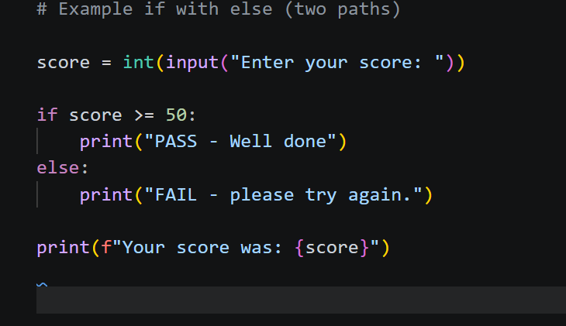

if → else is like fork in the road. One path or the other. Never both. Never neither
if the condition is True → take the if path
if the contion is False → tafe the else path

The code after(not indented) always runs regardless of which path was taken

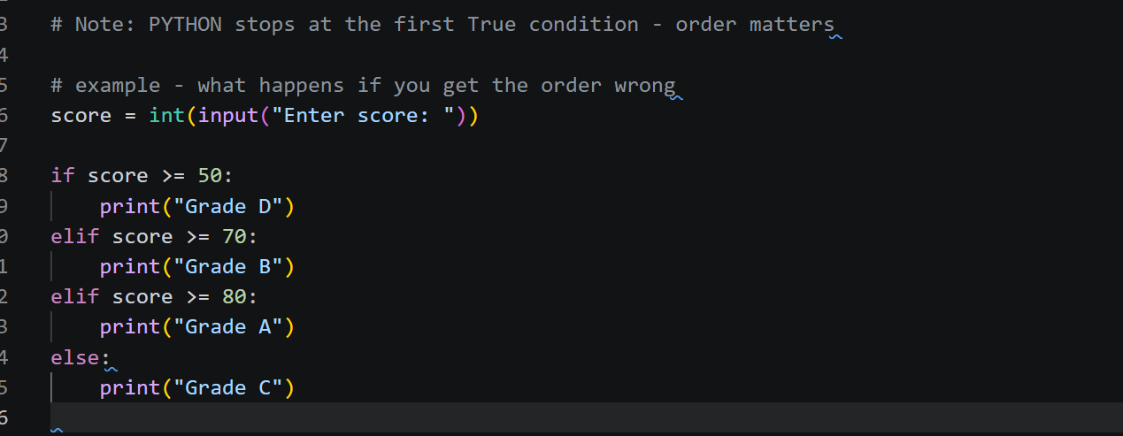

Most common mistake. Always check the MOST SPECIFIC(highest) condition first
Then work your way down to the least specific

Topic 3 - Logical operators , and, or ,not

Sometimes one condition is not enough. You need to check two things at once
and - BOTH condition must be True
or - AT LEAST ONE condition must be True
not - flips True to False and False to True

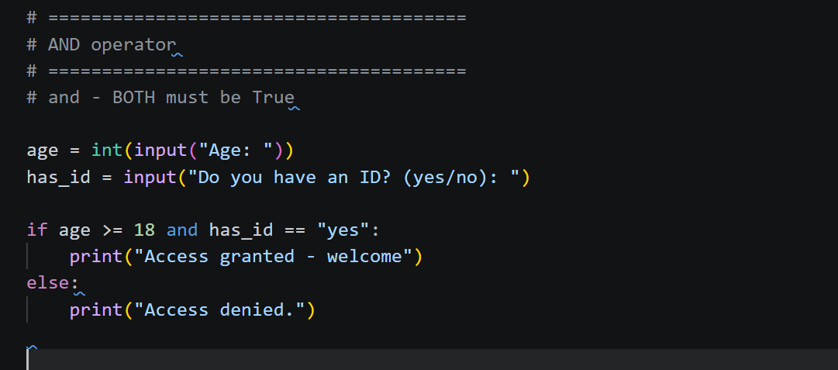

and truth table
True and True → True
True and False → False
False and True → False
Fasle and Fasle → False

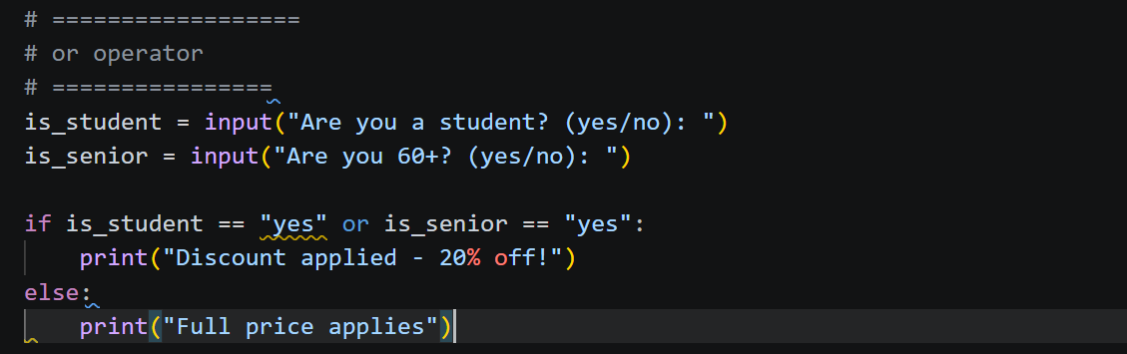

or truth table
True or True → True
True or False → True
False or True → True
False or False → False

